

**ENCEPT PREMEDIA**

**Artwork Approval Process**

**Help Document**

|  |  |
| --- | --- |
| **Document Type** | Help Document |
| **Version** | 1.0 |
| **Date** | 06-10-2018 |
| **Author** | Encept Team |

UPL-New Artwork Approval

Table of Content

1. Workflow Process- Artwork Approval

1.1 Client Reviewers 1

1.2 Client Brand Manager Approval 4

2. Workflow Process- Artwork Approval
   1. Client Reviewers

Clients will have their views as:

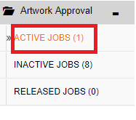

Figure 1.1: Views of Client

* **ACTIVE JOBS** viewis your landing page view, which is your (inbox).
* **INACTIVE JOBS** view is the view which shows workflow status pending with Encept either for holding the job by Encept from Client or Artwork Rejection or Revision.
* **RELEASED JOBS** view shows the Jobs that has been released by Encept for print.

Clicking on Active Jobs, clients can view the request form and can take decision either for

* **Accept:**

You can do the following:

**ACCEPT:**

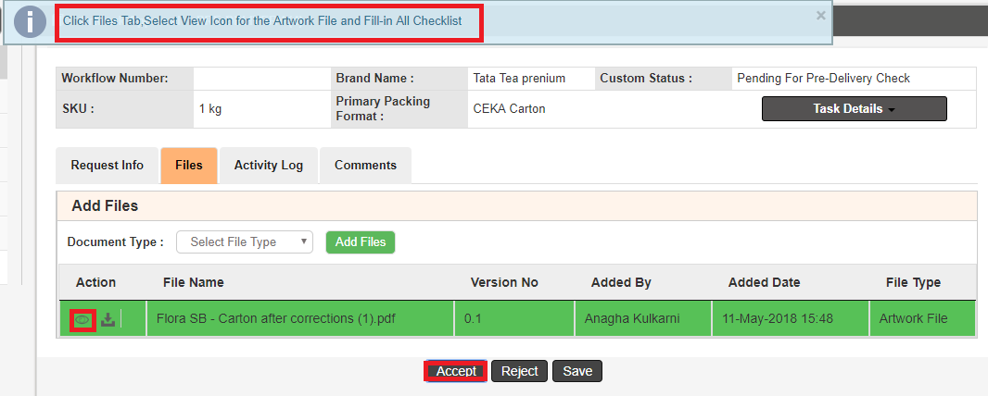

Figure 1.2 Accept & Review Artwork File

* On clicking Accept, validations message shows how to review the details uploaded by the other user.
* On the Files tab, Select the **Artwork** File and Click  Viewer icon to view the artwork in Viewer.

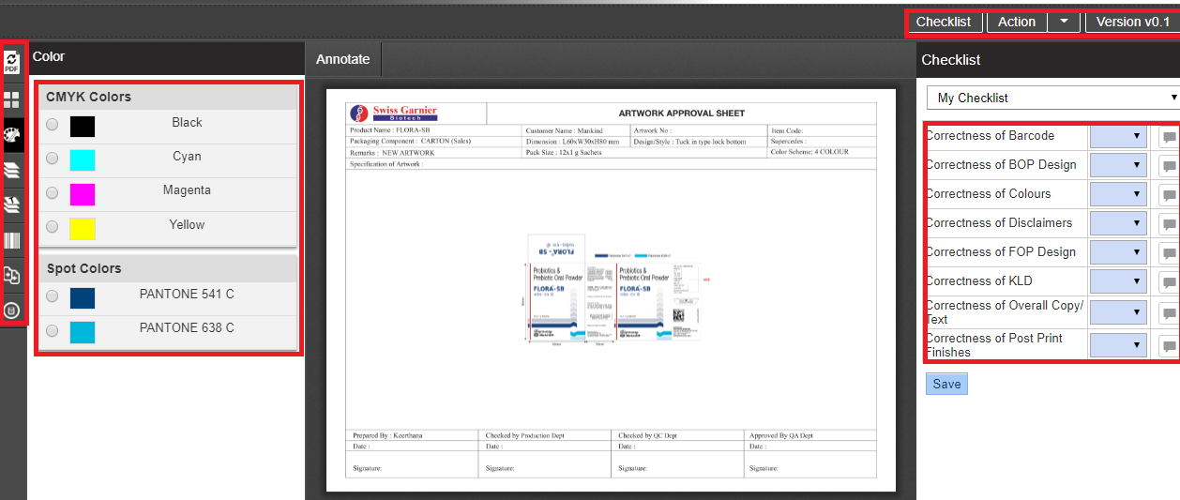

Figure 1.3: Viewer

* On the Viewer left hand side, you can view all the viewer functionalities like

**PDF Viewer, Thumbnail View, Color Separation, Layer separation, Font Separation, Barcode Details, Image Compare, Metadata.**

* On the right hand side, you can view the checklist.
* Every checklist will have Yes/No/NA option available. User can select the required option from the checklist drop down. Comments must be made when a particular checklist as “No” so to give the Reason.

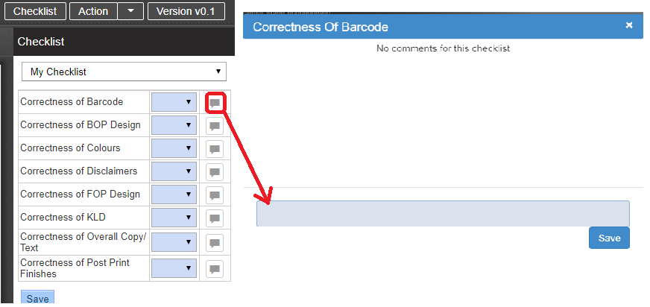

Figure 1.4: Files tab

* Click Save to save the checklist reviews in the form.
* Close the viewer window, go back to the main form click on Accept to submit the workflow to the Client Brand Manager for final Approval.
* **Reject:**

By giving comment, reason for rejection of the artwork as shown below.

**COMMENTS:**

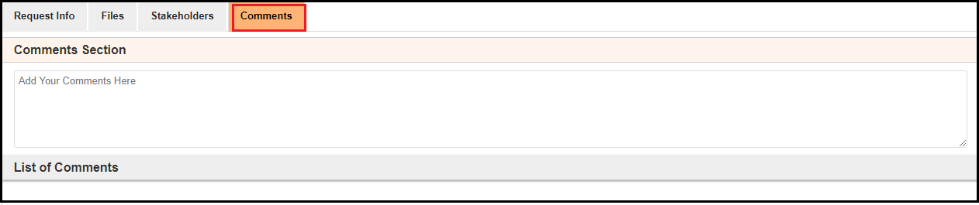

Figure 1.5: Comments Section

1. Enter the required comments in the **Comments** text box.
2. Once you submit the form, on the right hand side you can view the Comments in the **List of Comments** with user name, date and time.

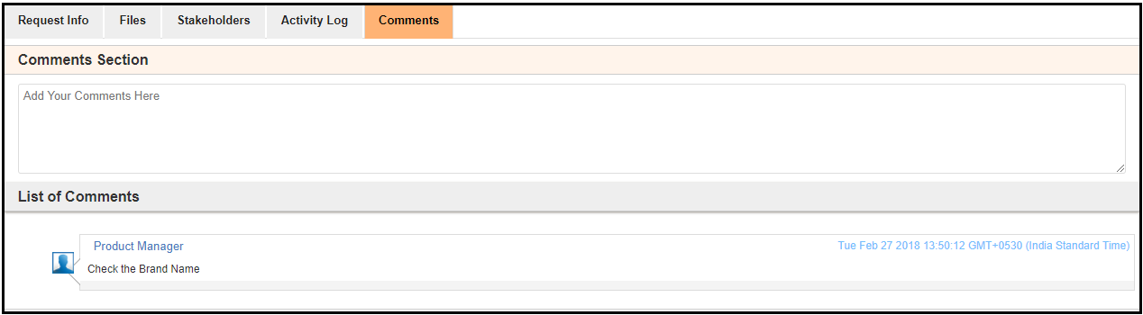

Figure 1.6: Add Comments

* You can also click **Save** to save the form for further use.
* Each reviewer’s will do the same steps and submit to the **Client Brand Manager** for final **Artwork Approval.**
* You can view in Activity Log, who is the next user in the workflow process**.**

**1.2 Client Brand Manager Approval**

You can do the following:

1. Ifyou **reject**, then it will go back to **Encept’s Inactive Jobs view** for updating the artwork and then for pre delivery check, before sending it to client reviewers**.**
2. If **approve,** then workflow will go to the **Encept’s Inactive Jobs** for artwork review and release to print.

* **Reject:** It will ask you to comment on reason for rejection.

**COMMENTS:**



Figure 1.7: Comments Section

1. Enter the required comments in the **Comments** text box.
2. Once you submit the form, on the right hand side you can view the Comments in the **List of Comments** with user name, date and time.



Figure 1.8: Add Comments

* **Approve:**

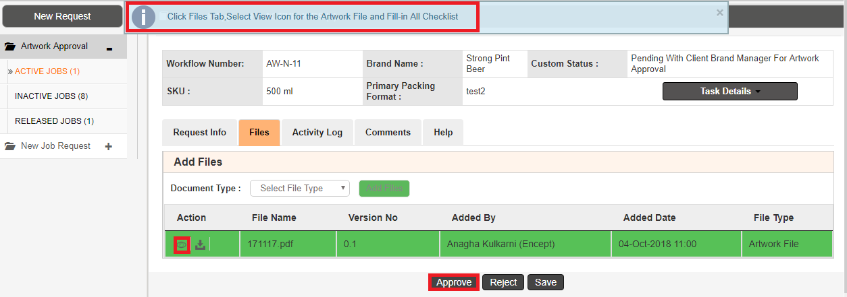

Figure 1.9: Accept & Review Artwork File

* On clicking Approve, validations message shows how to review the details uploaded by the other user.
* On the Files tab, Select the **Artwork** File and Click  Viewer icon to view the artwork in Viewer.



Figure 1.10: Viewer

* On the Viewer left hand side, you can view all the viewer functionalities like

**PDF Viewer, Thumbnail View, Color Separation, Layer separation, Font Separation, Barcode Details, Image Compare, Metadata.**

* On the right hand side, you can view the checklist.
* Every checklist will have Yes/No/NA option available. You can select the required option from the checklist drop down to make your decision. Comments must be made when a particular checklist as “No” so to give the Reason.



Figure 1.11: Files tab

* Click Save to save the checklist reviews in the form.
* Close the viewer window; go back to the main form click on Accept to submit the workflow to the Encept Account Manager/Executive.