

**ENCEPT PREMEDIA**

**Artwork Approval Process**

**Help Document**

|  |  |
| --- | --- |
| **Document Type** | Help Document |
| **Version** | 1.0 |
| **Date** | 10-06-2018 |
| **Author** | Encept |

UPL-New Artwork Approval

Table of Content

1. Workflow Process- Artwork Approval 1

1.1 Encept Account Manager/Executive (Initiator) 1

1.2 PRE-DELIVERY 8

1.3 Initiator Review 10

1.4 PRE-DELIVERY (if rejected by Initiator Review) 12

1.5 Client Reviewers 13

1.6 Client Brand Manager Approval 14

1.7 Encept Account Manager/Executive 14

1.8 Release 15

1.9 Archive 17

2. Workflow Process- Artwork Approval
   1. Encept Account Manager/Executive (Initiator)

Encept Account Manager/Executive users has the privilege to initiate the workflow. This section explains how to initiate the workflow.

To initiate do the following:

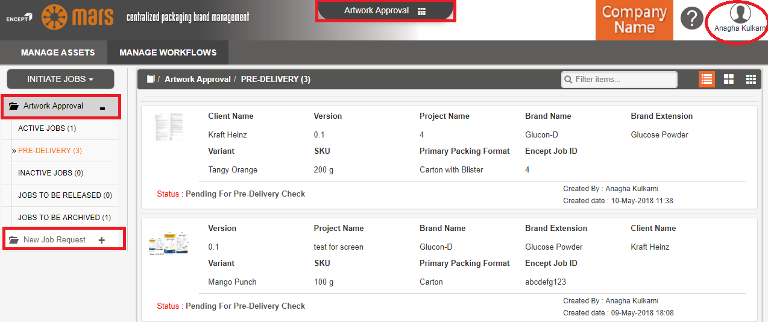

Figure 1.1: Application

* Login to the application. Left hand side shows the workflows present in the application. Right top corner shows the logged in user. Middle top shows the client name. (Refer Fig: 1.1)

**To Initiate JOB’s (Main Form) do the following:**

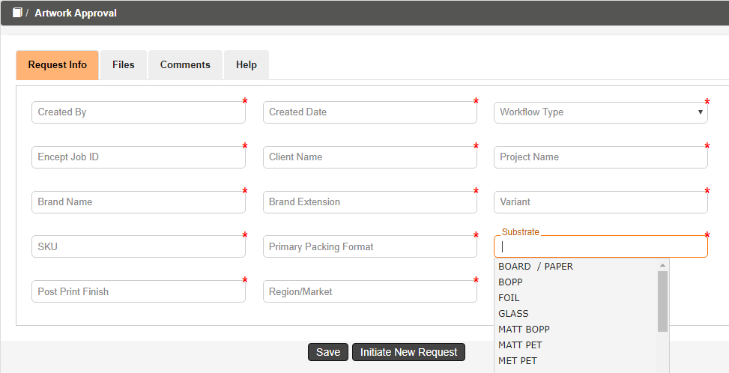

Figure 1.2.1: New request form (New)

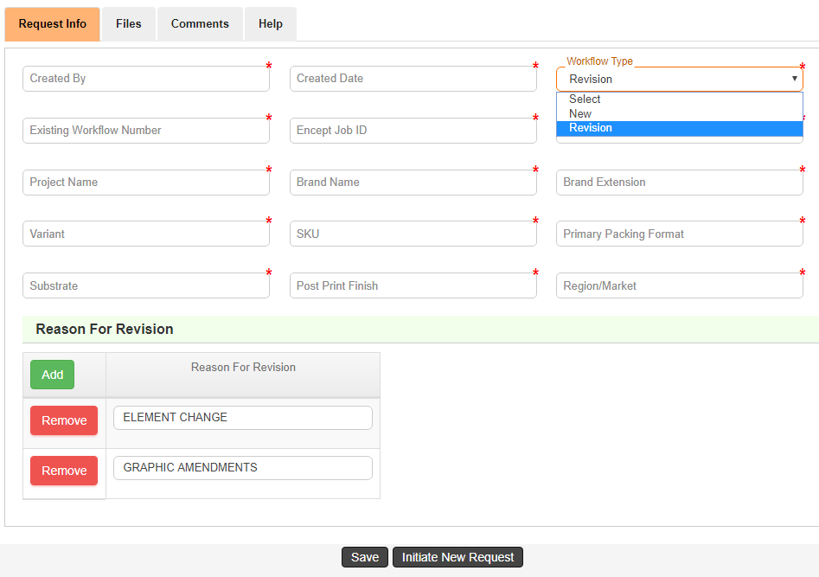

Figure 1.2.2: New request form (Revision)

* You can initiate new jobs by clicking Initiate Jobs, under that the workflow process to be chosen.
* **Created By** and **Created Date** fields are auto populated. **Created By** display based on the user who Login to the application and **Created Date** display the current date.
* Select the required type of workflow (New/Revision) in the **Workflow Type** autosuggestsdrop down.
* Enter the **Encept Job ID** in the particular text box.
* Select the required client name in the **Client Name** autosuggestsdrop down.
* Enter the **Project Name** in theparticular textbox**.**
* Select the required brand name in the **Brand Name** auto suggestsdrop down which is based on client name.
* Select the required brand extension in the **Brand Extension** auto suggestsdrop down which is based on brand name.
* Select the required variant in the **Variant** auto suggestsdrop down which is based on brand name.
* Select the required variant in the **SKU** auto suggestsdrop down which is based on brand name.
* Select the required value from **Primary Packaging Format** auto suggestsdrop down.
* Select the required value from **Substrate** auto suggestsdrop down.
* Select the required value from **Post Print Finish** auto suggestsdrop down.
* Select the required value from **Region/Market** auto suggestsdrop down.
* If Workflow type is Revision, **Existing Workflow** **Number** Field will be visible where we need to select the existing workflow numbers for which Artwork Revision is required.
* **Reason For Revision** field will be visible for Workflow Type Revision.
* **Reason For Revision** Details,
  + 1. Click  icon to add additional Reason for Revision.
    2. Click  icon to remove the added Reason for Revision.

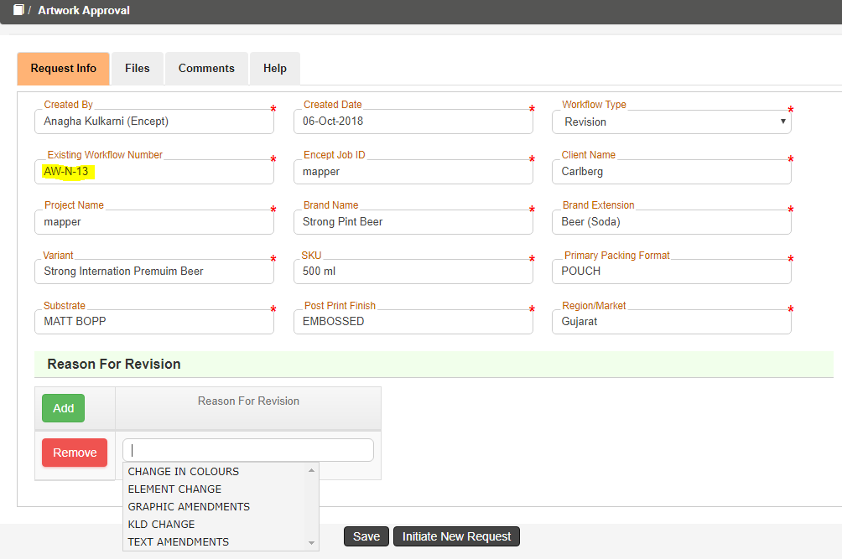

Figure 1.2.3: New request form (Revision)

* If Workflow Type is Revision selected, all the form field values will be populated same as, based on the selected existing workflow in existing workflow number.

**Views:**

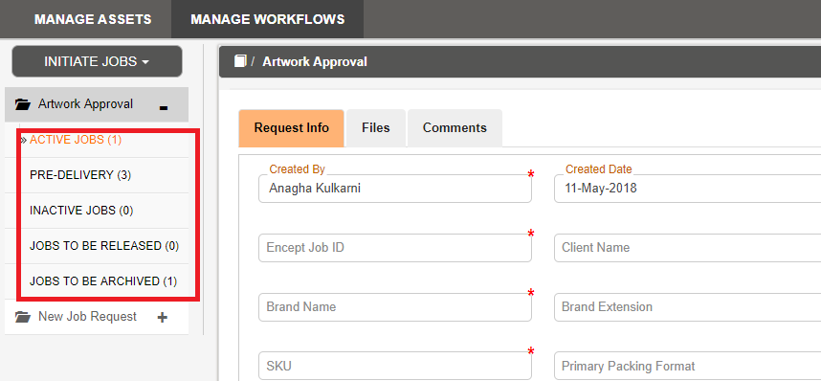 *Figure 1.3: Views*

* **Active Jobs** is the landing page for Encept Users, which shows the jobs pending with clients.
* **Pre-Delivery** view is for verifying the Artwork File before sending it to client by Encept.
* **Inactive Jobs** view contains jobs that is in *Hold* and which comes to Encept from Client for *Revision*.
* **JOBS TO BE RELEASED** contains jobs, which are approved by both Client and Encept and are ready to get released to Printers.
* **JOBS TO BE ARCHIVED** contains the job with *Artwork Technical Specifications*.

**FILES**:

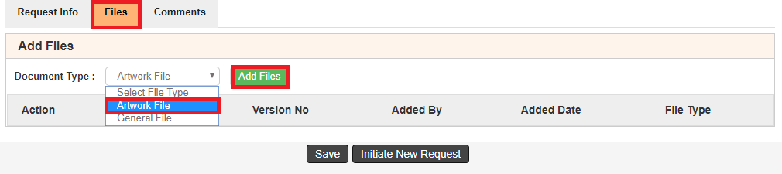

Figure 1.4.1: Add Files (Workflow type New)

Click **Files** tab to attach the document.

* Select the File type from the **Document Type** drop down list.
* Click the **Add Files** button.
* Once the user clicks the Add Files and the following below pop up will appear.

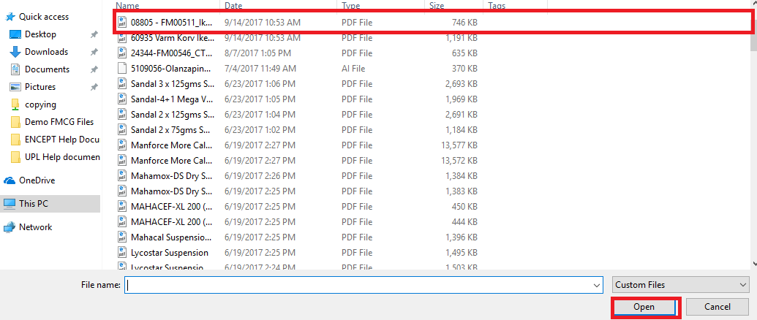

Figure 1.5: Select Files

* You can select the required files and click **Open** to attach the required file.
* User can view the attached file under the file section.

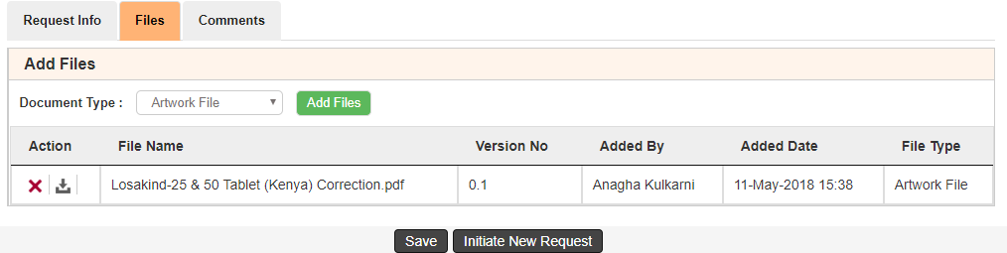

Figure 1.6: Files Section

1. Click delete icon to delete the required file.
2. Click  download icon to download the Files.
3. **File Name** indicates the name of the attached file in the file section.
4. **Version No** indicates the version of the attached file.
5. **Added By** indicates who uploads the File.
6. **Added Date** indicates the file uploaded date.
7. **File Type** indicates the type of attached file

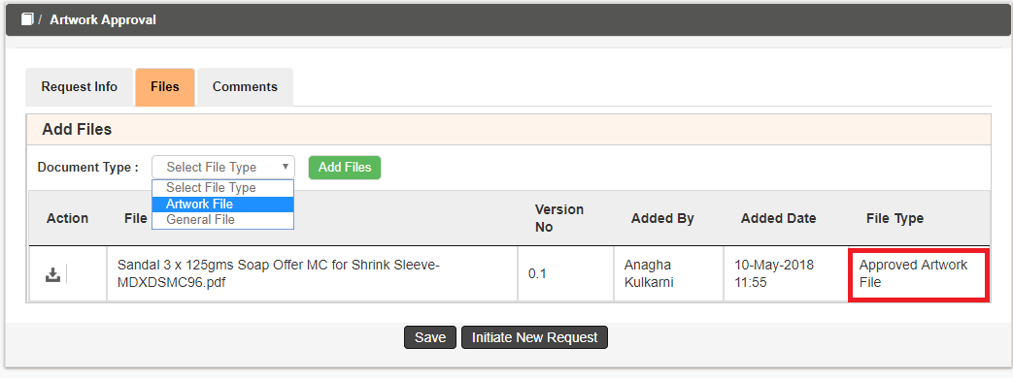

Figure 1.4.2: Add Files (Workflow type Revision)

* If workflow type is Revision, Approved Artwork Files will also be populated according to Existing Workflow number.
* Then Attach Artwork Files as mentioned above.

**COMMENTS:**

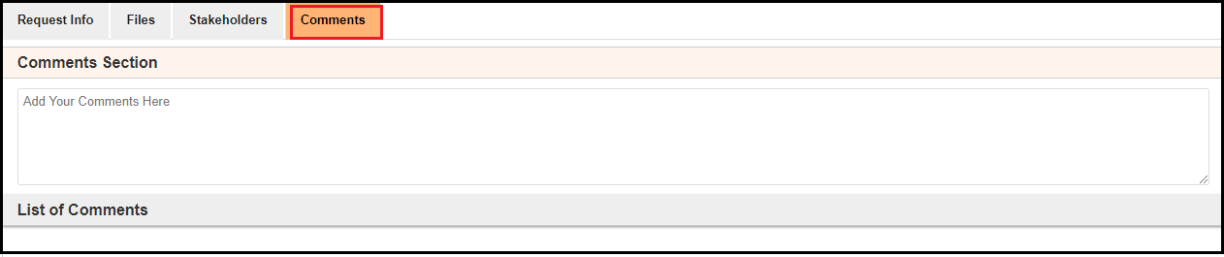

Figure 1.7: Comments Section

1. Enter the required comments in the **Comments** text box.
2. Once you submit the form, on the right hand side you can view the Comments in the **List of Comments** with user name, date and time.

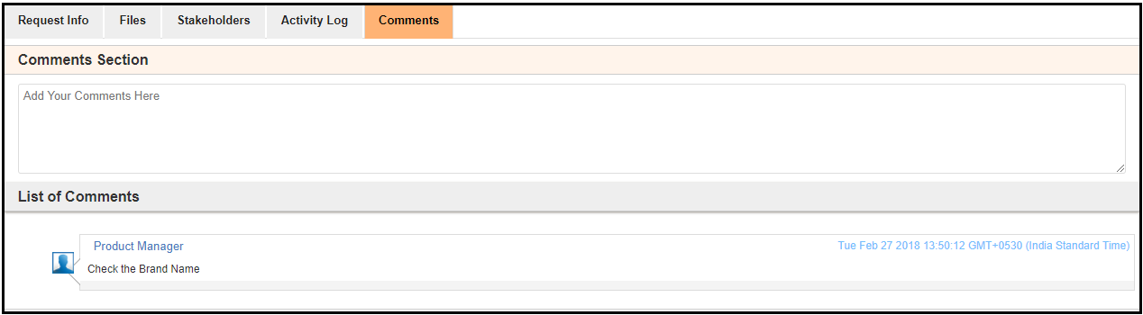

Figure 1.8: Add Comments

You can do the following:

1. Click **Save** to save the form.
2. Click **Initiate New Request** to submit the request form.

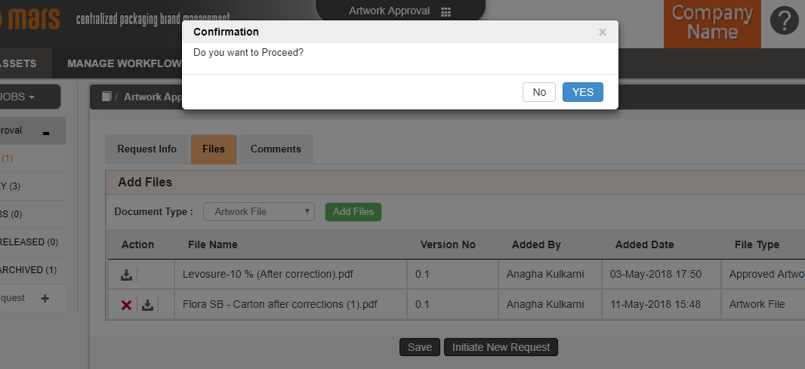

Figure 1.9: Confirmation Message Alert

After form submission, workflow submitted message displays as shown below:

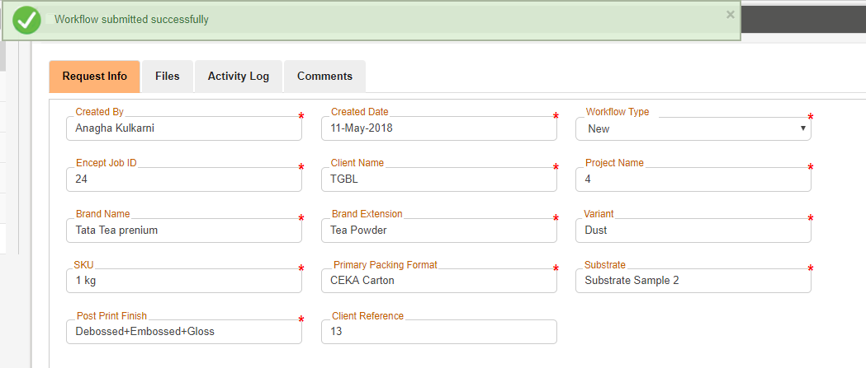

Figure 1.10: Workflow Submitted

Click **Activity Log** tab to view the history of the request form.

On the History Page,

It displays the Activity Name, Participant Name, Actual Start Date, Actual End Date and Action.

You have successfully initiated the process.

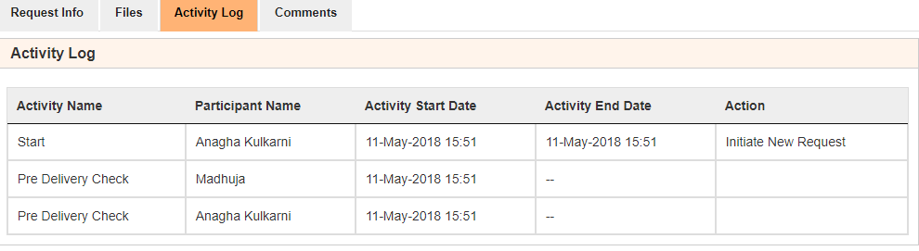

Figure 1.11: view history

* 1. **PRE-DELIVERY**

Once the initiator submits the form, then the workflow moves to the Encept Pre Delivery to review the Artwork file. This section explains how to upload the files.

In this activity, the uploaded Artwork File is pre checked before delivering to Clients.

* Select **PRE-DELIVERY** under the Artwork Approval taband click the required pending request form.
* You can view the **form field** details of the respective pending request.

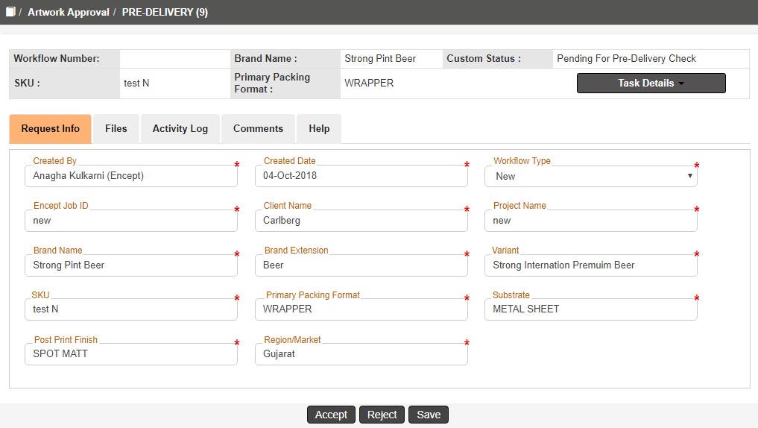

Figure 1.12: Pre-Delivery Request Form

* On the top you can see the quick view of the details like **Brand Name, Custom Status, SKU, Primary Packaging Format, Task Details** of the respective workflow.
  + 1. **ACCEPT:**

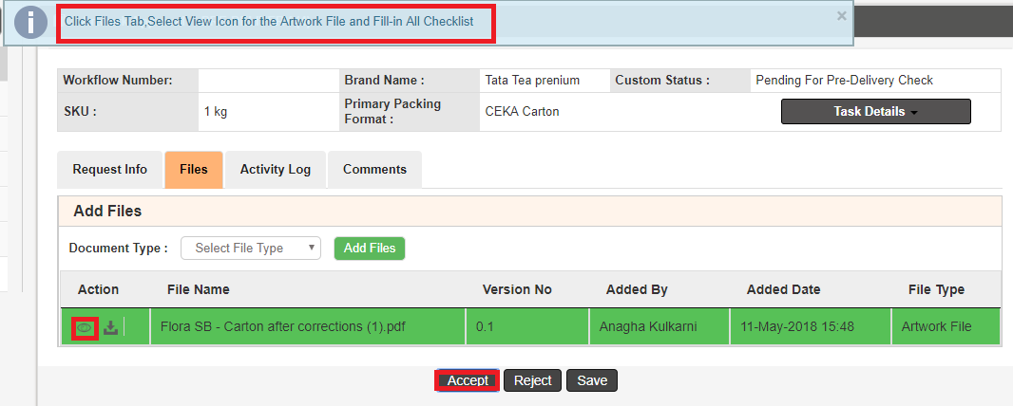

Figure 1.13: Accept & Review Artwork File

* On clicking Accept validations message shows how to review the details uploaded by the other user.
* On the Files tab, select the **Artwork** File and Click  Viewer icon to view the artwork in Karomi Viewer.

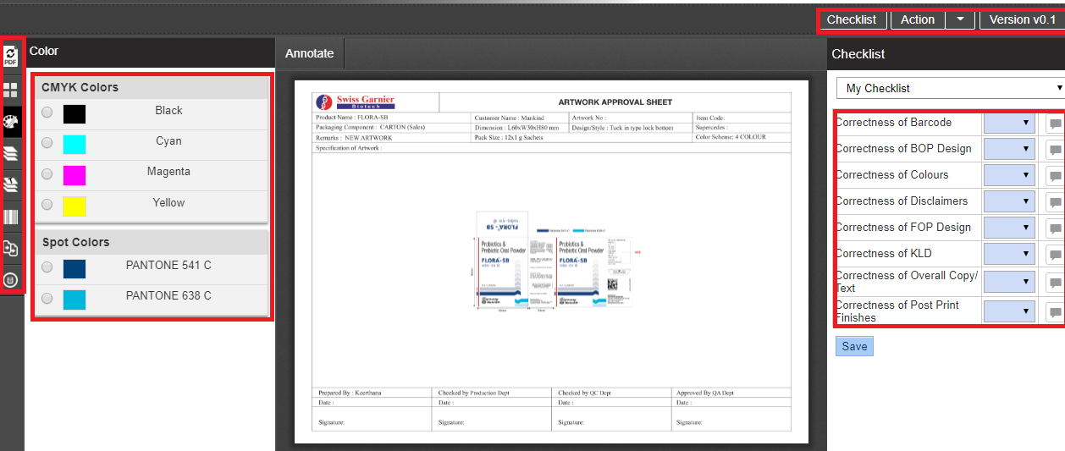

Figure 1.14: Karomi Viewer

* On the Karomi Viewer left hand side, you can view all the viewer functionalities like

**PDF Viewer, Thumbnail View, Color Separation, Layer separation, Font Separation, Barcode Details, Image Compare, Metadata.**

* On the right hand side, you can view the checklist.
* Every checklist will have Yes/No/NA option available. User can select the required option from the checklist drop down. Comments must be made when a particular checklist as “No” so to give the Reason.

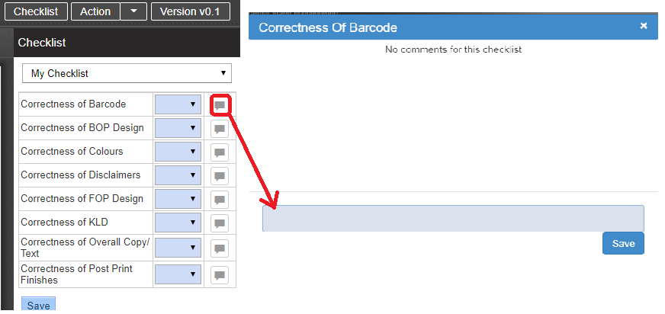

Figure 1.15: Files tab

* Click Save to save the checklist reviews in the form.
* Close the viewer window, go back to the main form click on Accept to submit the workflow to the clients.

**1.2.2 Reject:**

* Enter the reason for rejection in the comment section.
* The request will go back to the Initiator for Review.

**1.3 Initiator Review**

In this section, Initiator will review the artwork file, if not correct then he will update a new artwork file.

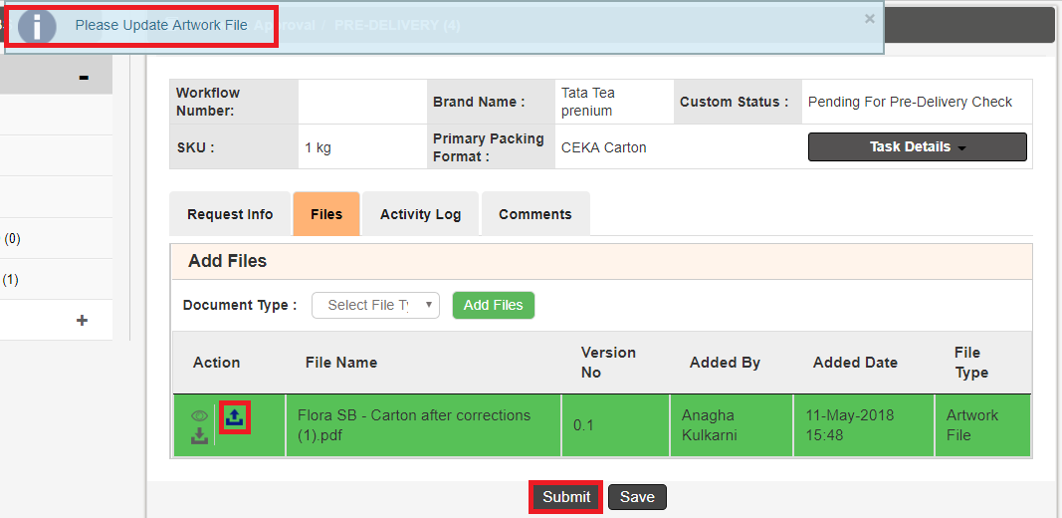

Figure 1.16: File Update

* Once you click on submit it will show validation message for updating the file where  is the update icon.



Figure 1.17: Select Files

* Clicking on update icon will take you to the above image files where you need to select files and click open then selected file will be updated and automatically internal version have changed with success message as shown below.

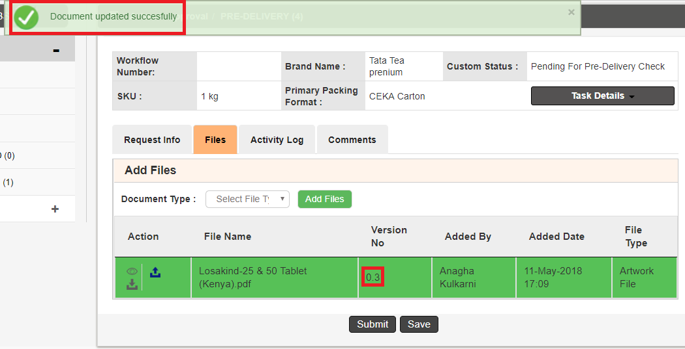

Figure 1.18: Version Number Changed

You can do the following.

1. Click **Save** to save the request form in your inbox.
2. Click **Submit** to submit the request form to Pre Delivery Check.
3. Click Activity Log tab to view the history of the request form.

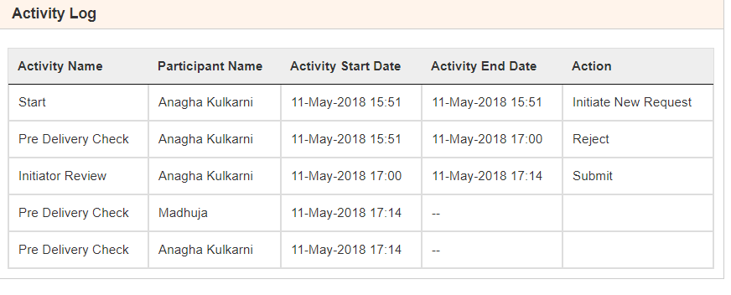

Figure 1.19: View history

**1.4 Pre-Delivery (If Rejected by Initiator Review)**

* You will again review the file through checklist using view icon.
* If accepted, then workflow will move to clients.
* Once artwork is approved by Encept Unique Workflow Number will be generated as shown below:

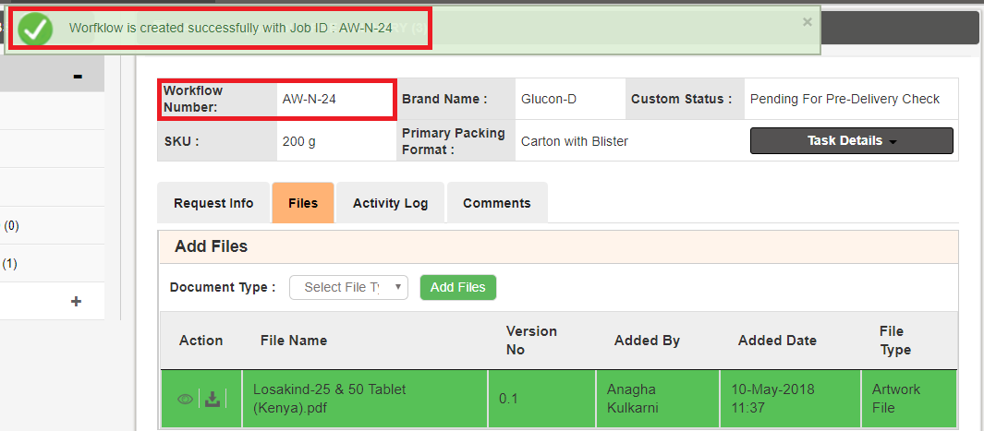

Figure 1.20: Workflow Number generated

You can click on Active Jobs to check with which client user workflow is pending. Refer below image:

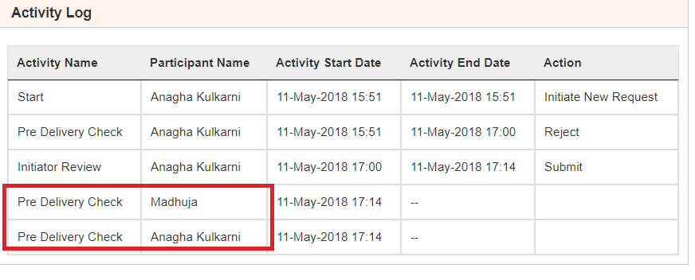

Figure 1.21: View history

**1.5 Client Reviewers**

Clients will have their views as:

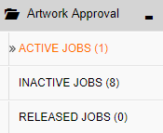

Figure 1.22: Views of Client

* **ACTIVE JOBS** viewis their landing page view which is their (inbox).
* **INACTIVE JOBS** view is the view which shows workflow status pending with Encept.
* **RELEASED JOBS** view shows the workflows released by Encept.

Clicking on Active Jobs, clients can view the request form and can take decision either for

* **Accept:**

They can do the following:

Review the artwork file using checklist by clicking view icon ** .**

* **Reject:**

By giving comment, reason for rejection of the artwork.

Each reviewer’s will do the same steps and submit to the **Client Brand Manager** for final **Artwork Approval.**

**1.6 Client Brand Manager Approval**

He can do the following:

1. Ifhe **rejects**, then it will go back to **Encept’s Inactive Jobs view** for updating the artwork and then pre delivery check, same process continues**.**
2. If **approves,** then workflow will go to the **Encept’s Inactive Jobs** for artwork review.

**1.7 Encept Account Manager/Executive**

He will review the artwork by clicking the view icon  , using the checklists.

In this activity, form fields to be entered are “Artwork Source File Path” & “Printer Mail ID”

He can do the following:

**Release:**

Release the workflow to the next activity.

**Re-Initiate:**

Send back the workflow to the Encept Account Executive/Manager, for updating new artwork and Re-Initiate the workflow, then goes to Pre Delivery Check for Artwork Review and same process continues.

On the Printer Mail ID,

1. Click  icon to add additional Printer Mail ID.
2. Click  icon to remove the added Printer Mail ID.
3. Select the required unique Mail ID from the auto suggest drop down as shown above.
4. If Workflow Type is Revision, Printer Mail ID will be auto populated which was selected on the existing workflow. You can change it or add additional.

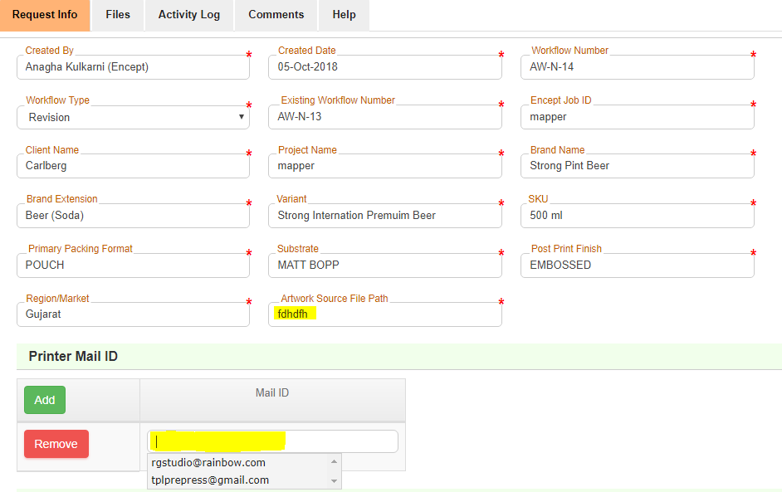

*Figure: 1.23 Pre Release*

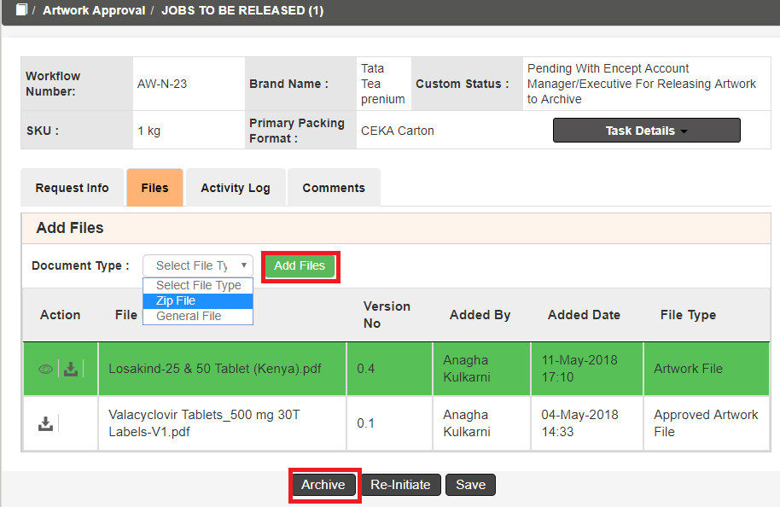

*Figure 1.24: ADD Zip File*

Click on Add File to add file in .zip format as shown below:

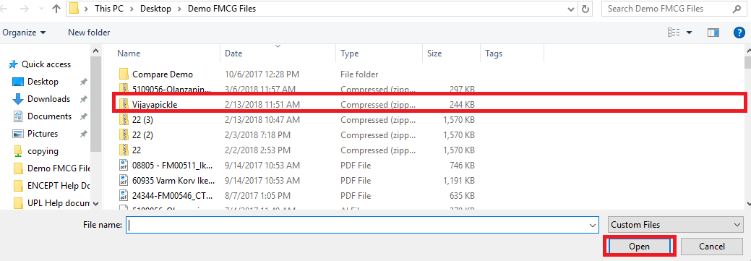

*Figure 1.25: File Section*

Click on open to add files in the form shown below.

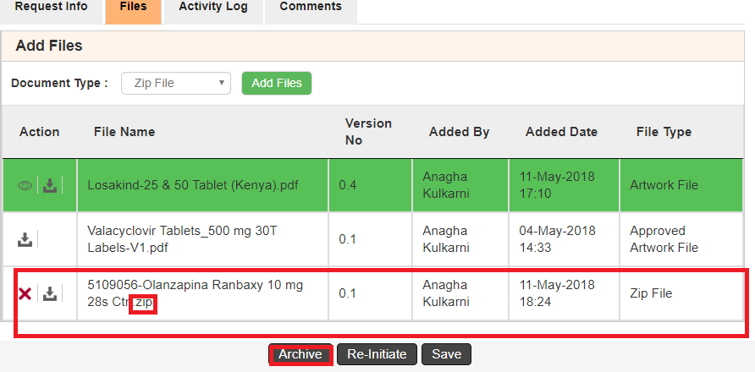

*Figure 1.26: Zip File Attached*

* Click delete icon to delete the required file and attach again.
* Click  download icon to download the Files

**1.8 Release**

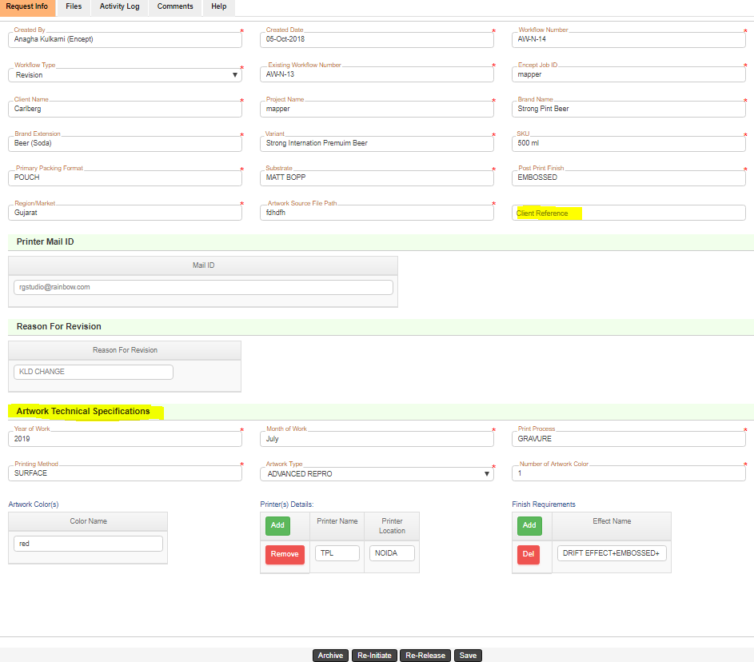

Figure 1.27: Release Form

Here, Artwork Technical Specifications to be filled like **Year of Work, Month of Work, Print Process, Printing Method, Artwork Type, Number of Artwork Color, Artwork Colors, Printer Details and Finish Requirements**

Here, Encept users need to fill the form fields under Artwork technical specifications like:

1. **Year of Work** needs to be selected from autosuggest drop down.
2. **Month of Work** needs to be selected from autosuggest drop down.
3. **Print Process** needs to be selected from autosuggest drop down.
4. **Printing Method** needs to be selected from autosuggest drop down.
5. **Artwork Type** needs to be selected from autosuggest drop down.
6. **Number of colors** need to be entered**.**
7. **Artwork Color(s) need** to be entered.
8. Based on the value entered in **Number of colors**, so many text fields will be generated for **Artwork color(s)** field like below**:**

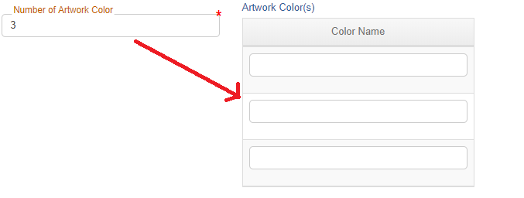

*Figure 1.28: Artwork Color(s)*

1. **Printer Name** needs to be selected from autosuggest drop down.
2. **Printer Location** needs to be selected from autosuggest drop down.
3. **Finish Requirements** need to be selected from autosuggest drop down.

In this activity, following decision can be taken:

**Archive:**

Send to next activity for archival.

**Re-Initiate:**

Send back the workflow to the Encept Account Executive/Manager, for updating new artwork and Re-Initiate the workflow, then goes to Pre Delivery Check for Artwork Review and same process continues.

**Re-Release:**

Sending back to previous activity for releasing with correct zip file or Printer mail ID or artwork source file path.

* 1. **Archive**

In Archive activity, Encept needs to verify the data given in the Release activity before closing the job in the Artwork Technical Specification part.

Here all the data are auto populated from previous activity and can be edit.

In this activity, **Client Reference** field is non-mandatory.

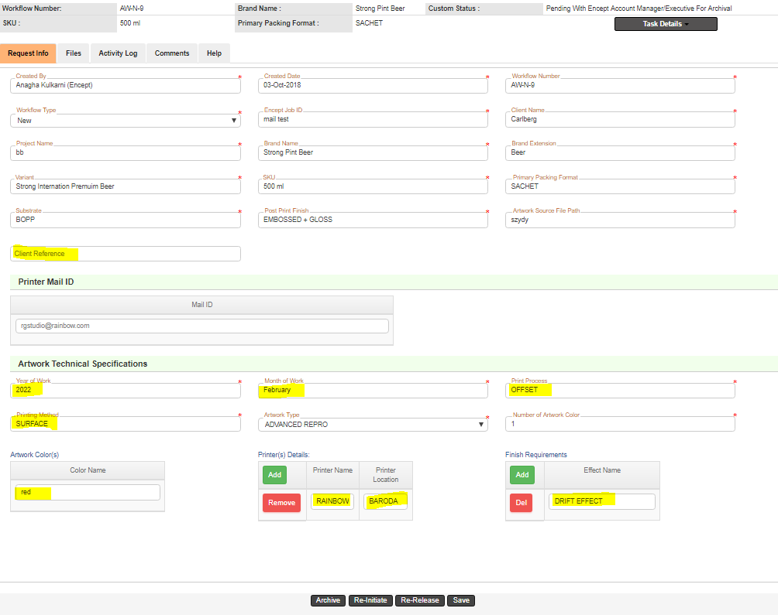

*Figure 1.29: Archive Form*

In this activity the following decisions can be taken:

* **Close Job:** End of the workflow process.
* **Re-Initiate:** Send back the workflow to the Encept Account Executive/Manager, for updating new artwork and Re-Initiate the workflow, then goes to Pre Delivery Check for Artwork Review and same process continues.
* **Re-Release:** Send back to Release Activity for any change in mail ID or re attaching of Zip file.
* **Save:** Can save the file in your inbox (Jobs To Be Archived) and can review later.

Once Close Job is clicked success message will show like this:

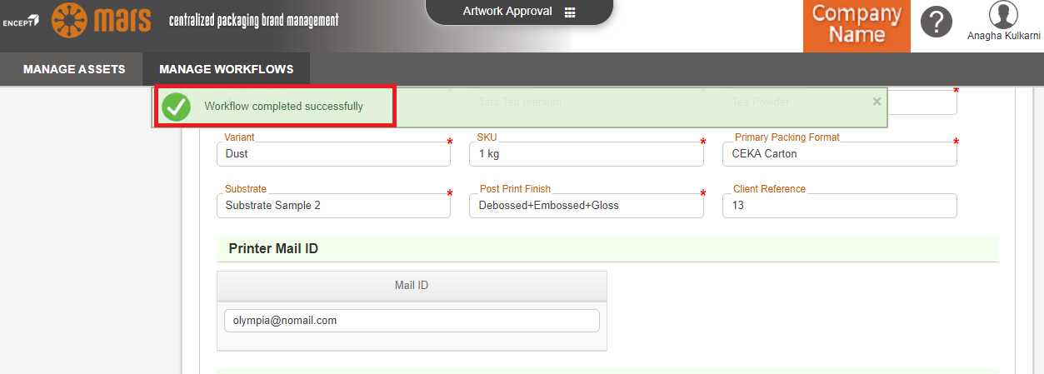

*Figure 1.30: Workflow Completion Message*

You can check in the activity log for the full process activity details as shown below:

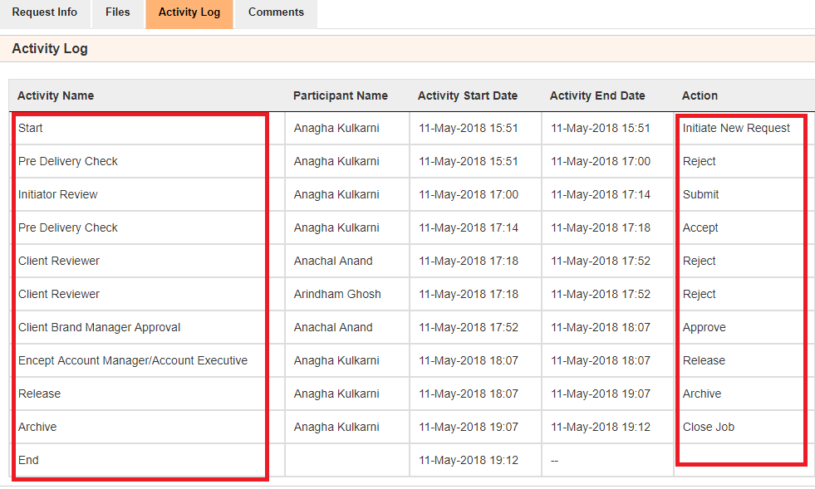 *Figure 1.31: View History*

**MANAGE ASSETS:**

Once workflow is submitted, files will move into Manage Assets Library where all the approved artworks will be stored. Refer below:

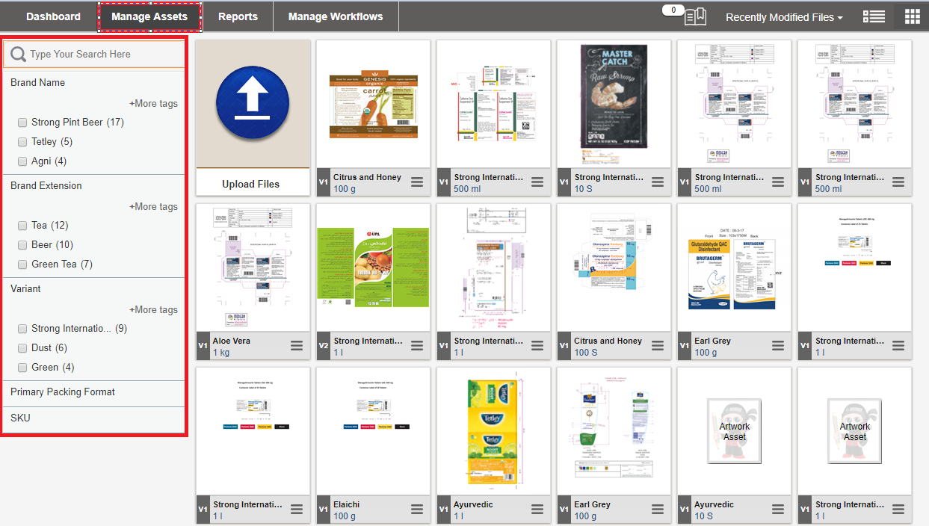

*Figure 1.32: Manage Assets*

Left hand side are the form fields, which can be used to filter files based on the input data.

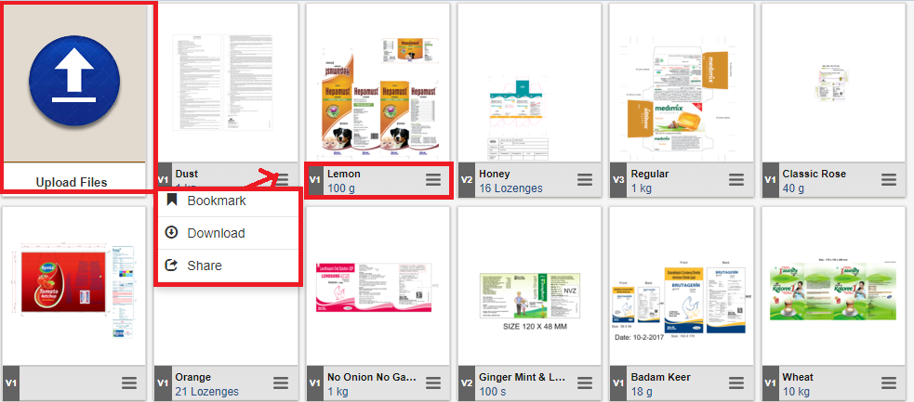

*Figure 1.33: Manage Assets Properties*

* Left top is the icon for Upload File from Manage Assets. You can upload multiple files together at a time.
* You can click on “Click Here to Search More” to add more form fields.
* Upload All icon will upload all the files together.

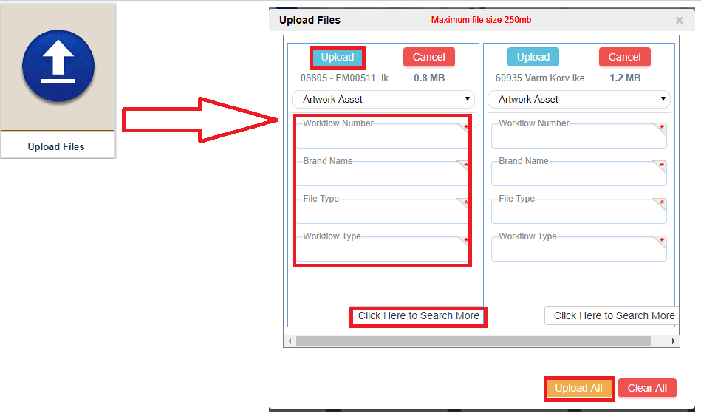

*Figure 1.34: Upload file from Manage Assets*

* Second red marked are the options that can be done to a particular file like **Bookmark** the file, **Download** the File, **Share** to particular users.

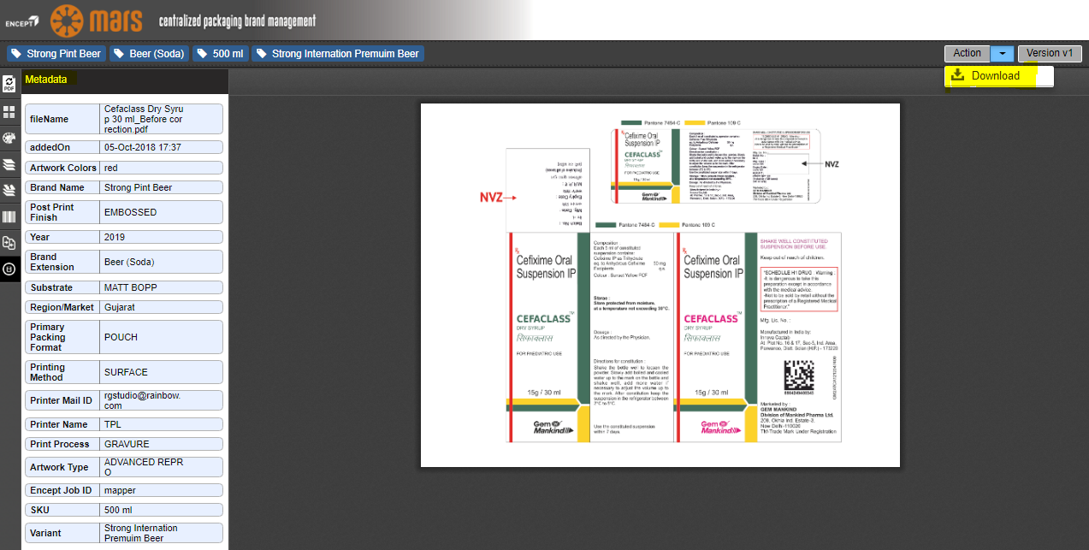

*Figure 1.35: Artwork from DAM in Viewer Window.*

Left side are the meta data of the file. Right top file can be downloaded.

HOLD:

You can hold the workflows pending with client from your Active Jobs View.

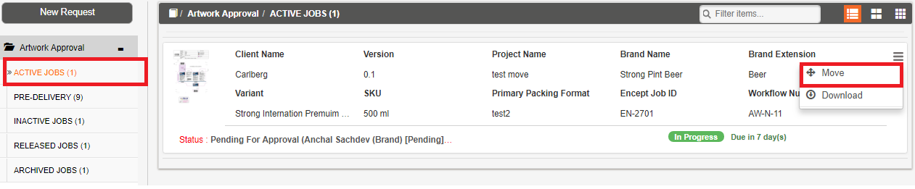

*Figure 1.36: Hold in Active Jobs.*

Click on Hold option to hold it to the following:

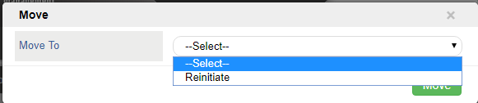

*Figure 1.37: Holding To, in Active Jobs.*

You can also hold the workflows pending in your Inactive Jobs View as shown:

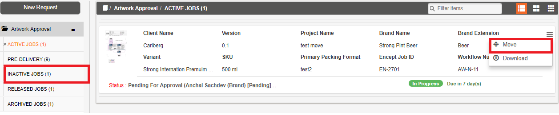

*Figure 1.38: Hold in Inactive Jobs.*

Click on Hold option to hold it to the following:

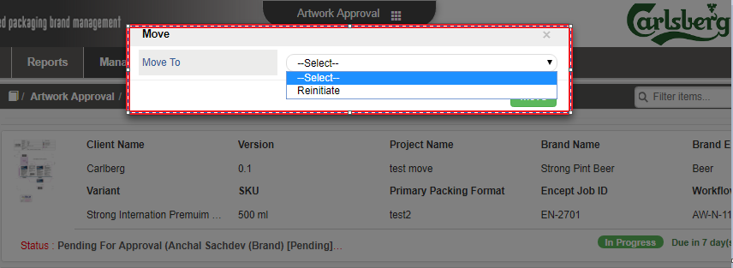

*Figure 1.39: Holding to, in Inactive Jobs.*

2. Workflow Process-New Job Request

2.1 Client Brand Manager (Initiator)

Client Brand Manager user has the privilege to initiates the workflow. This section explains how to initiate the workflow.

To initiate do the following:

1. Login to the application.

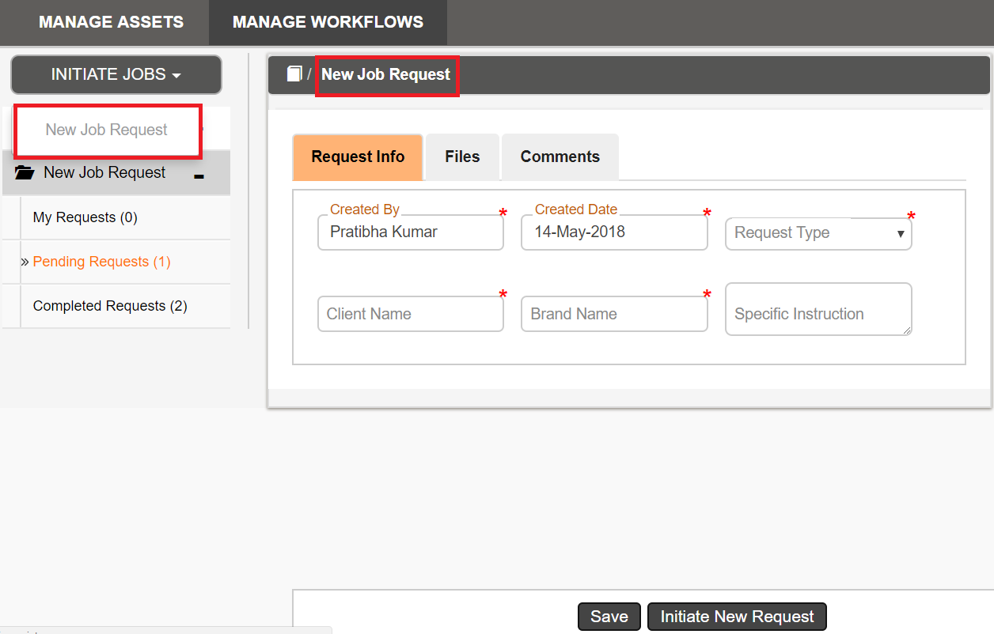

*Figure 2.1: Main Request Form*

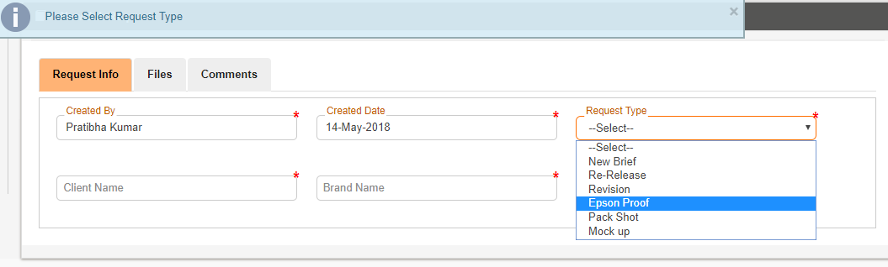

*Figure 2.2: Request Type*

Client Brand Manager can select 6 types of action to be performed on the artwork file being selected to be sent to the Encept.

**Files:**

Click **Files** tab to attach the document.

* Select the File type from the **Document Type** drop down list.
* Click the **Add Files** button.

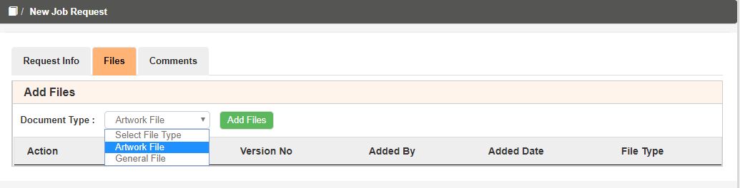

Figure 2.3: Add Files

1. Once the user clicks the Add Files and the following below pop up will appear.

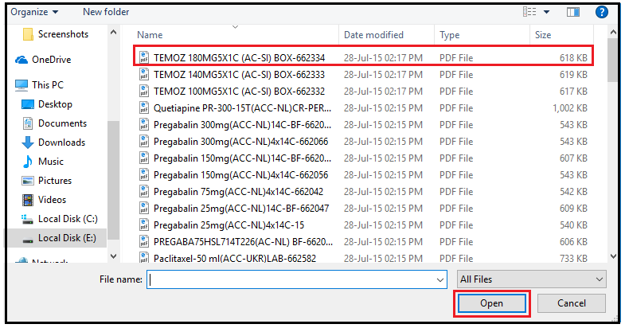

Figure 2.4: Select files

1. You can select the required files and click **Open** to attach the required file.
2. User can view the attached file under the file section.

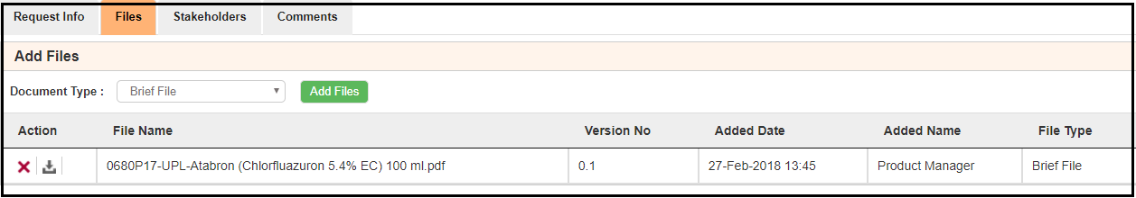

Figure 2.5: File section

1. Click delete icon to delete the required file.
2. Click  download icon to download the Files.
3. **File Name** indicates the name of the attached file in the file section.
4. **Version No** indicates the version of the attached file.
5. **Added Date** indicates the file uploaded date.
6. **Added Name** indicates who uploads the File.
7. **File Type** indicates the type of attached file.

**Request Type:**

* **New Brief**

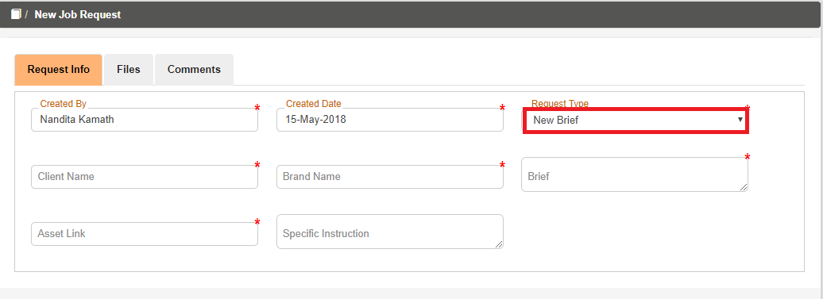

Figure 2.6: Main Form (New Brief)

On the **Request Info**,

1. **Created By** and **Created Date** fields are auto populated. **Created By** display based on the user who Login to the application and **Created Date** display the current date.
2. Select the required request type from the **Request Type** auto suggestsdrop down.
3. Select the required client name from the **Client Name** auto suggestsdrop down.
4. Select the required brand name from the **Brand Name** auto suggestsdrop down.
5. Enter the brief details in **Brief** text area.
6. Enter the asset link in the **Asset Link** Textbox.
7. **Specific Instruction** is non-mandatory field.

* **Re-Release**

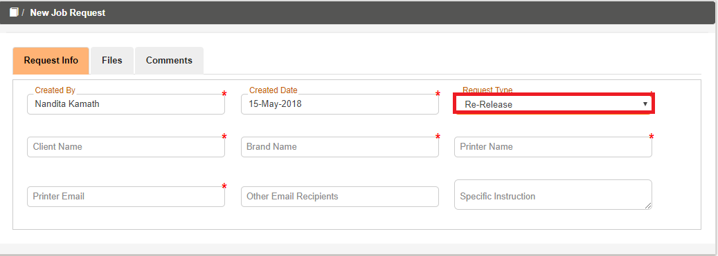

Figure 2.7: Main Form (Re-Release)

On the **Request Info**,

1. **Created By** and **Created Date** fields are auto populated. **Created By** display based on the user who Login to the application and **Created Date** display the current date.
2. Select the required request type from the **Request Type** auto suggestsdrop down.
3. Select the required client name from the **Client Name** auto suggestsdrop down.
4. Select the required brand name from the **Brand Name** auto suggestsdrop down.
5. Enter the respective printer name in **Printer Name** textbox.
6. Enter the respective printer mail id in **Printer Email** textbox.
7. Other Email Recipients and Specific Instruction fields are non-mandatory.

* **Revision**

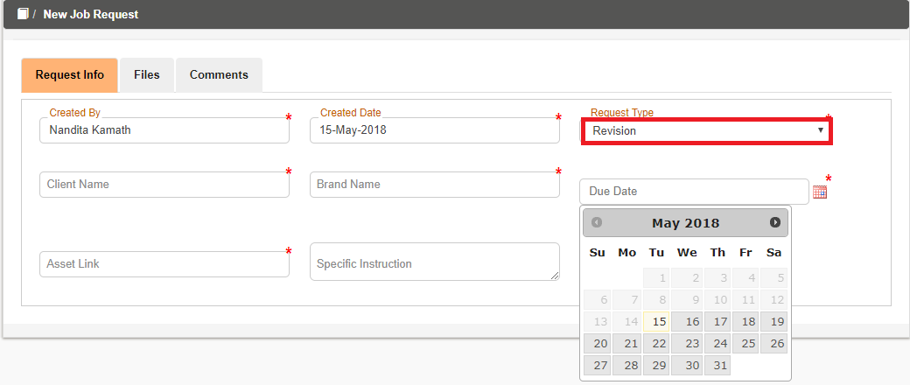 Figure 2.8: Main Form (Revision)

On the **Request Info**,

1. **Created By** and **Created Date** fields are auto populated. **Created By** display based on the user who Login to the application and **Created Date** display the current date.
2. Select the required request type from the **Request Type** auto suggestsdrop down.
3. Select the required client name from the **Client Name** auto suggestsdrop down.
4. Select the required brand name from the **Brand Name** auto suggestsdrop down.
5. Pick the **Due Date** from date picker.
6. Enter the asset link in the **Asset Link** Textbox.
7. **Specific Instruction** is non-mandatory field.

* **Epson Proof**

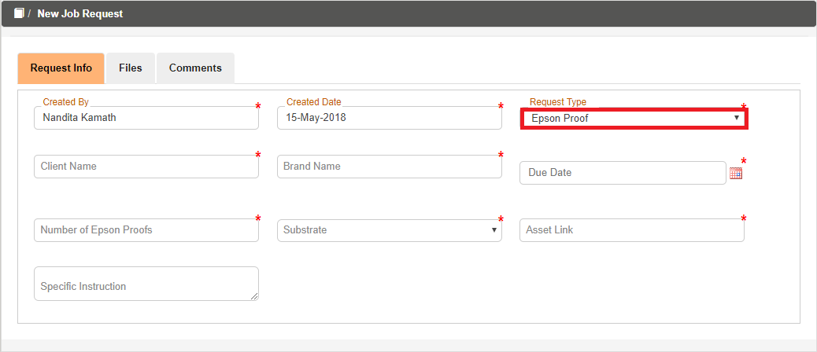

Figure 2.9: Main Form (Epson Proof)

On the **Request Info**,

1. **Created By** and **Created Date** fields are auto populated. **Created By** display based on the user who Login to the application and **Created Date** display the current date.
2. Select the required request type from the **Request Type** auto suggestsdrop down.
3. Select the required client name from the **Client Name** auto suggestsdrop down.
4. Select the required brand name from the **Brand Name** auto suggestsdrop down.
5. Pick the **Due Date** from date picker.
6. Enter the number of epson proofs required in **Number of Epson Proofs** text box.
7. Select **Substrate** from auto suggest drop down.
8. Enter the asset link in the **Asset Link** Textbox.
9. **Specific Instruction** is non-mandatory field.

* **Pack Shot**

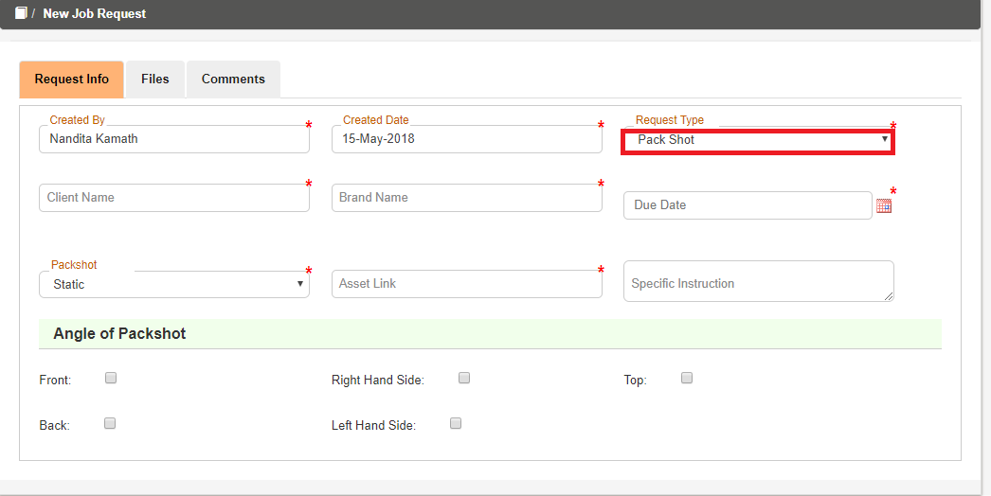

Figure 2.10: Main Form (Pack Shot)

On the **Request Info**,

1. **Created By** and **Created Date** fields are auto populated. **Created By** display based on the user who Login to the application and **Created Date** display the current date.
2. Select the required request type from the **Request Type** auto suggestsdrop down.
3. Select the required client name from the **Client Name** auto suggestsdrop down.
4. Select the required brand name from the **Brand Name** auto suggestsdrop down.
5. Pick the **Due Date** from date picker.
6. Select the required pack shot from the **Packshot** auto suggestsdrop down.
7. Enter the asset link in the **Asset Link** Textbox.
8. **Specific Instruction** is non-mandatory field.
9. At least **two** checkboxes need to be checked in **Angle of Packshot.**

* **Mock up**

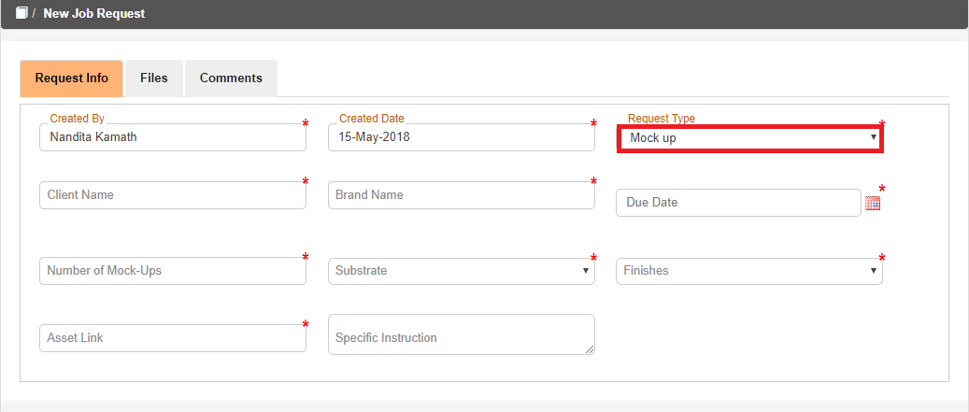

Figure 2.11: Main Form (Mock up)

On the **Request Info**,

1. **Created By** and **Created Date** fields are auto populated. **Created By** display based on the user who Login to the application and **Created Date** display the current date.
2. Select the required request type from the **Request Type** auto suggestsdrop down.
3. Select the required client name from the **Client Name** auto suggestsdrop down.
4. Select the required brand name from the **Brand Name** auto suggestsdrop down.
5. Pick the **Due Date** from date picker.
6. Enter number of mock-ups required in **Number of Mock-Ups text box.**
7. Select **Substrate** from auto suggest drop down.
8. Select **Finishes** from auto suggest drop down.
9. Enter the asset link in the **Asset Link** Textbox.
10. **Specific Instruction** is non-mandatory field.

**Files (non-mandatory):**

If client wants to mention the artwork file on which the above processes should take place, then they need to attach files like below:



*Figure 2.12: Add Files*

Click **Files** tab to attach the document.

* Select the File type from the **Document Type** drop down list.
* Click the **Add Files** button.
* Once the user clicks the Add Files and the following below pop up will appear.



Figure 2.13: Select Files

* You can select the required files and click **Open** to attach the required file.
* User can view the attached file under the file section.



Figure 2.14: Files Section

1. Click delete icon to delete the required file.
2. Click  download icon to download the Files.
3. **File Name** indicates the name of the attached file in the file section.
4. **Version No** indicates the version of the attached file.
5. **Added By** indicates who uploads the File.
6. **Added Date** indicates the file uploaded date.
7. **File Type** indicates the type of attached file
   1. **ENCEPT Account Manager/Executive**

You will get all the request details in main form from the Clients as below:

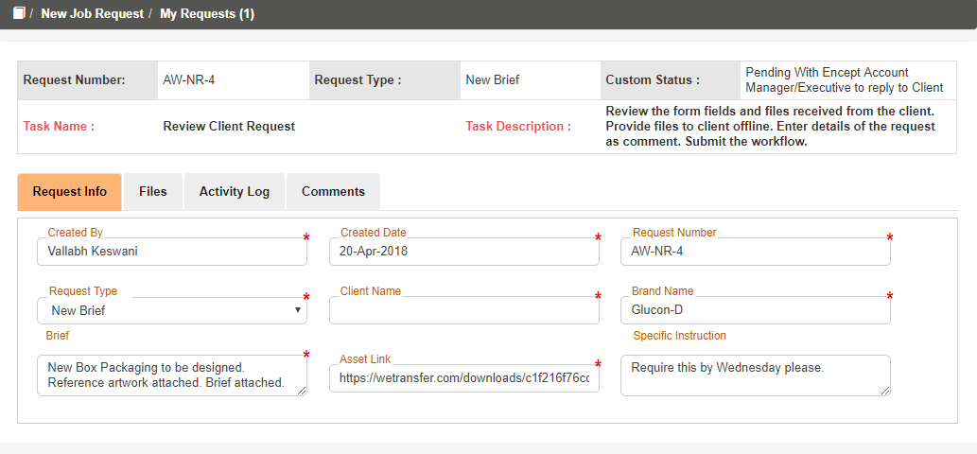

Figure 2.15: Files Section

You can work on it, and update the status by commenting in the comment section and submit back to the client.

**COMMENTS:**



Figure 2.16: Comments Section

1. Enter the required comments in the **Comments** text box.
2. Once you submit the form, on the right hand side you can view the Comments in the **List of Comments** with user name, date and time.



Figure 2.17: Add Comments

Click on submit button, to submit the form. After submitting you will get the following confirmation pop up:

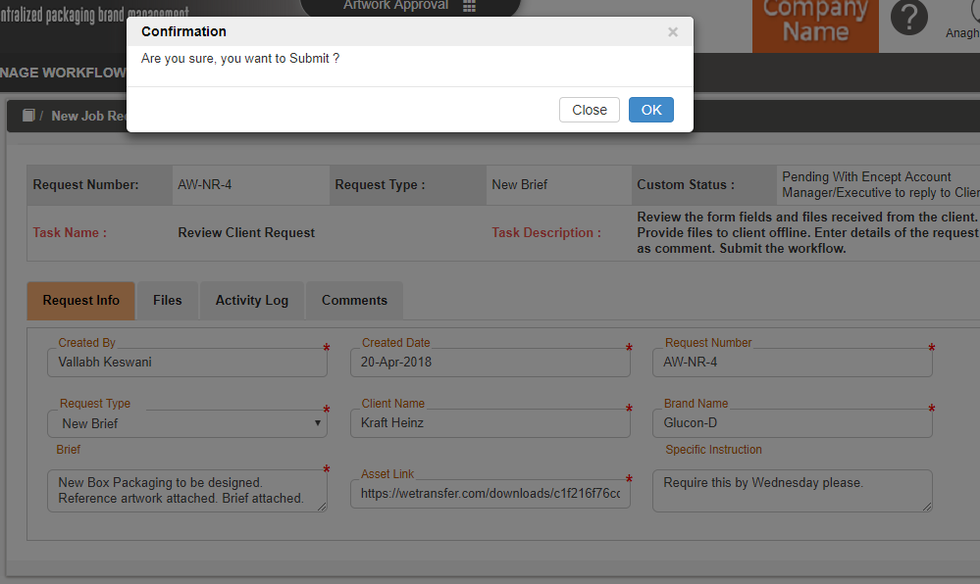

Figure 2.18: Confirmation Message

* 1. **Client Brand Manager**

Client Brand Manager will review the status of artwork and end the process by clicking on submit button.

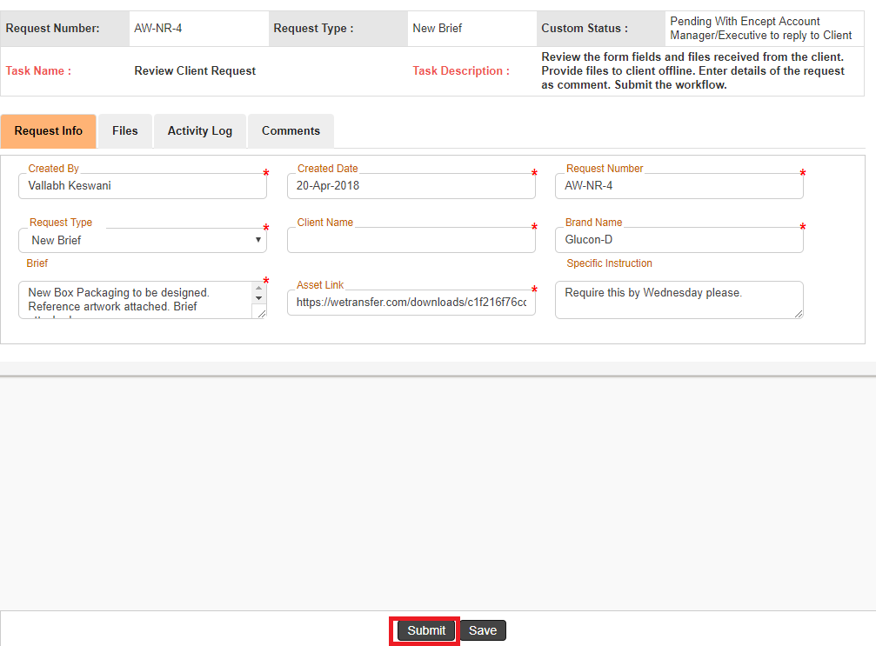

Figure 2.19: Main Form